- Create one IAM user and assign EC2 and S3 full access roles
Go to IAM Dashboard
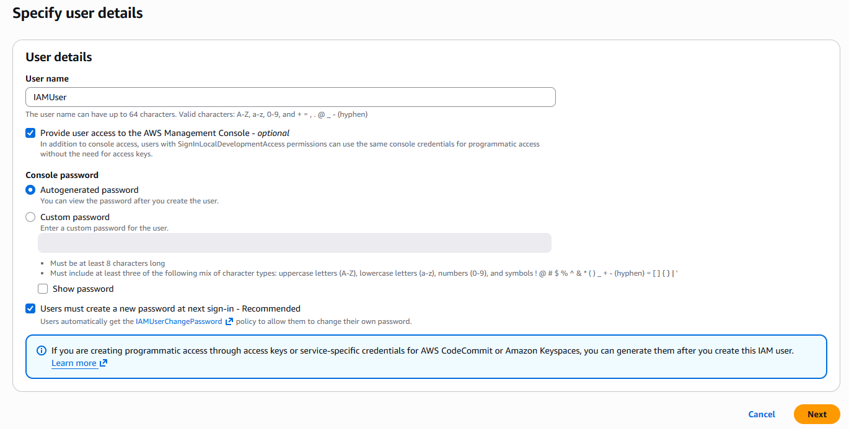
Now click on Next button
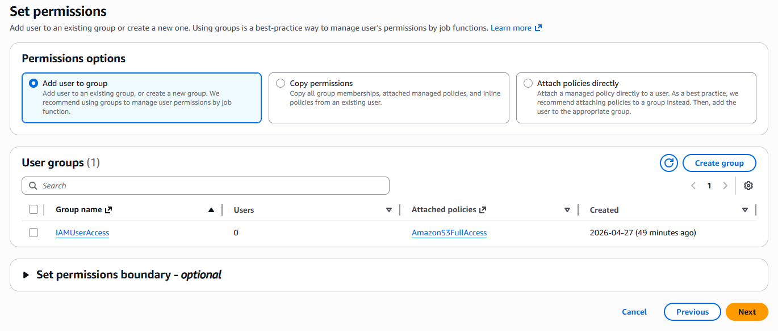
Now click on next button
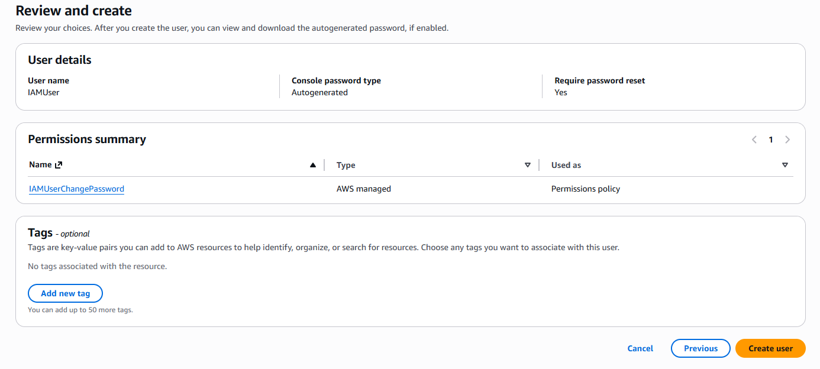
Now click on Create User button
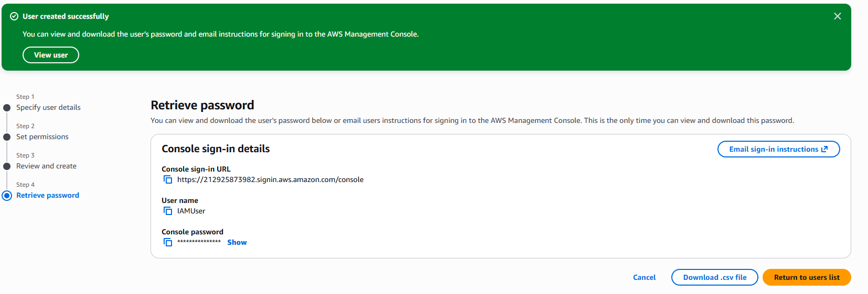
Now go to AWS Console web site login
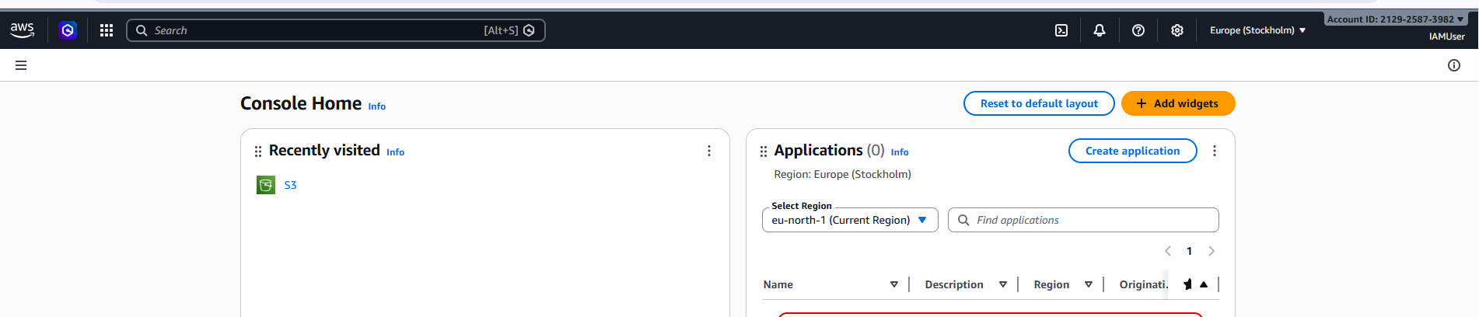
Now give EC2 and S3 full permission.

Click on Add Permissions button
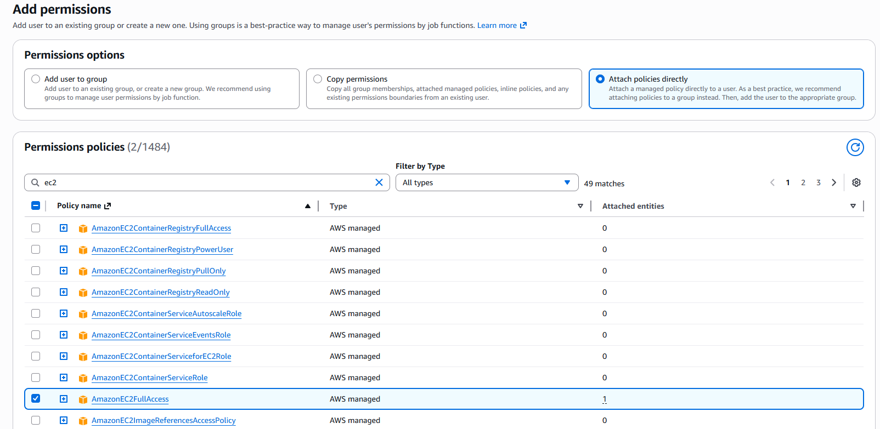
Now select Attach policies directly and In Permissions policies tab select EC2 and S3 and click on next button
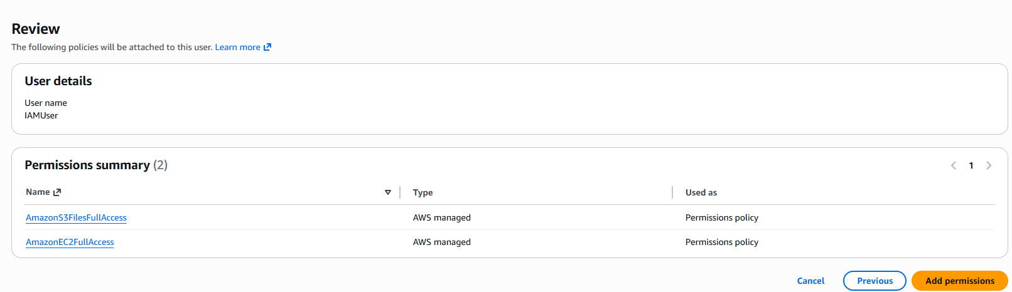
Now add permissions
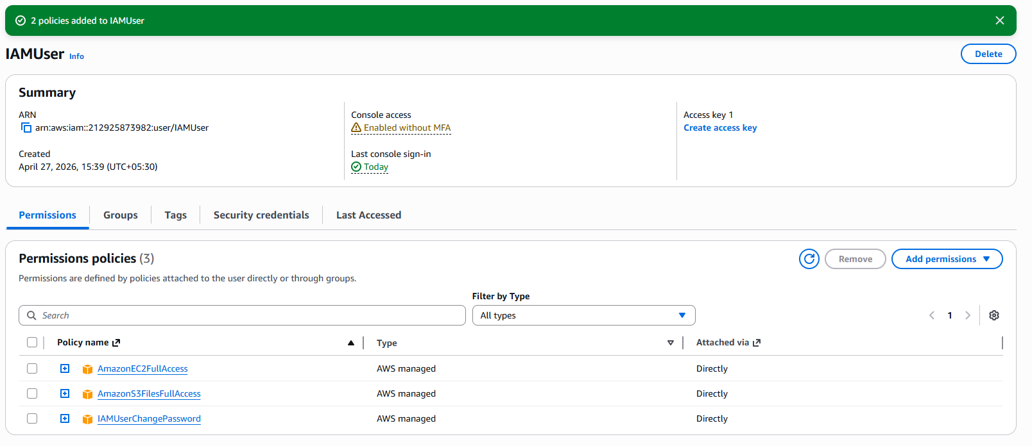

- Create one group in IAM and assign read access for EC2.
Go to IAM user group in left side menu add in group
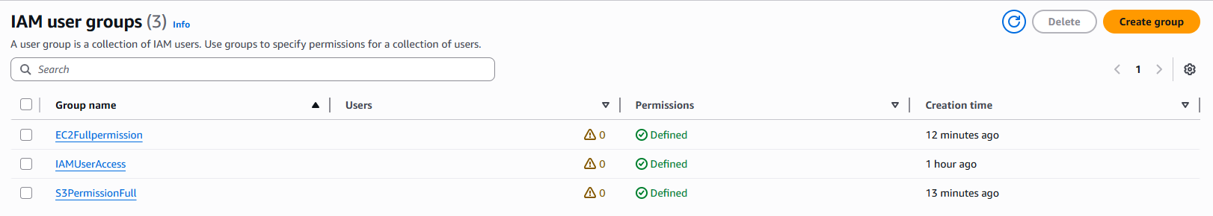
Create group button
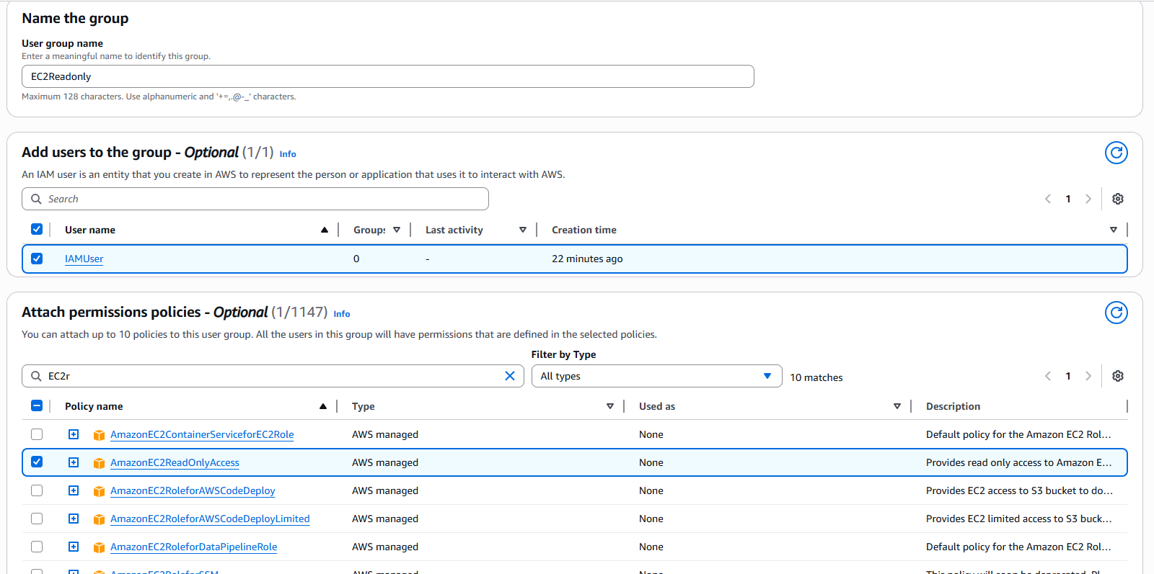
Now give group name and add user to in group. Attach permissions policies read only of ec2 instance.
Click on create user group button
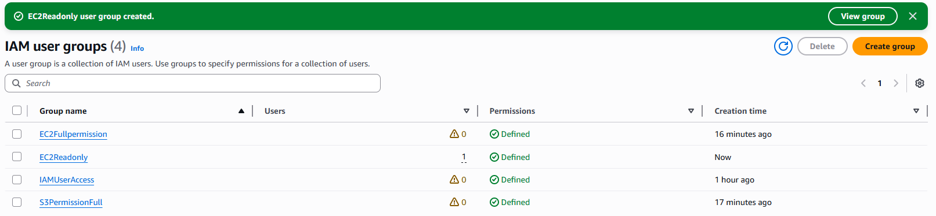

- Create a new user named "Devops" and add to the group created in task 2.
IAM User dashboard and click on Create user button
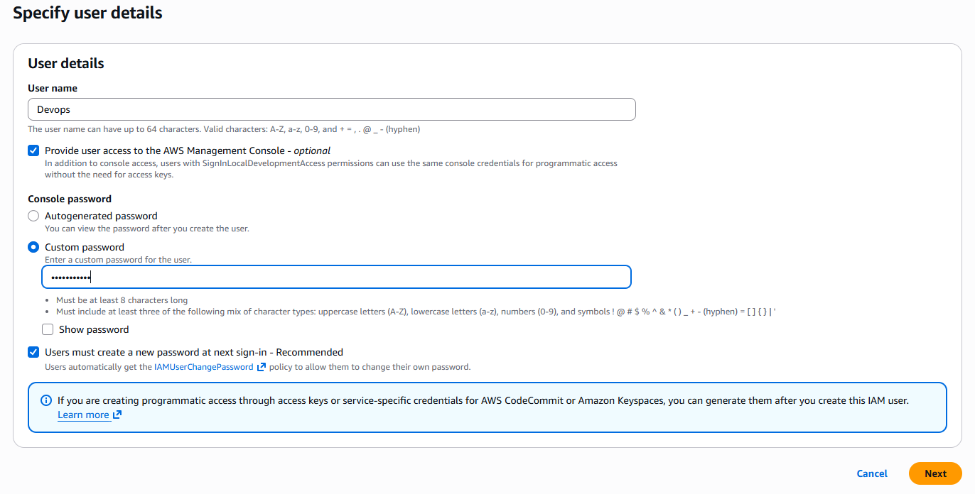
Click on next button
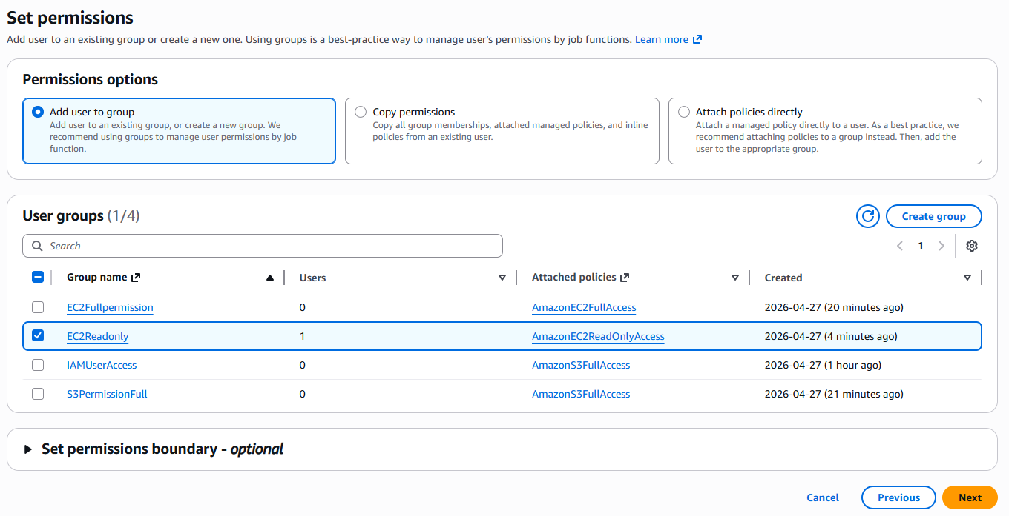
Now select group policy EC2Readonly. Policy added to Devops user and click on next button.
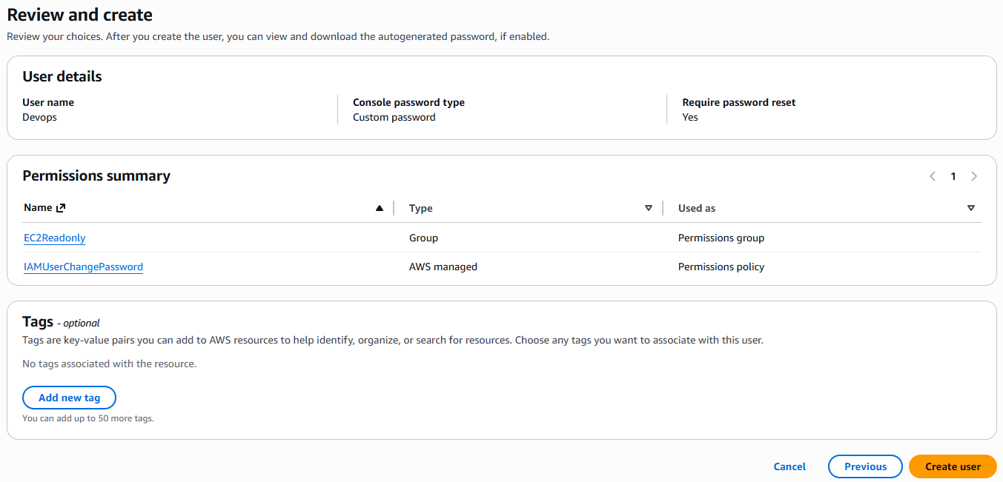
Now review the information and click on create user button
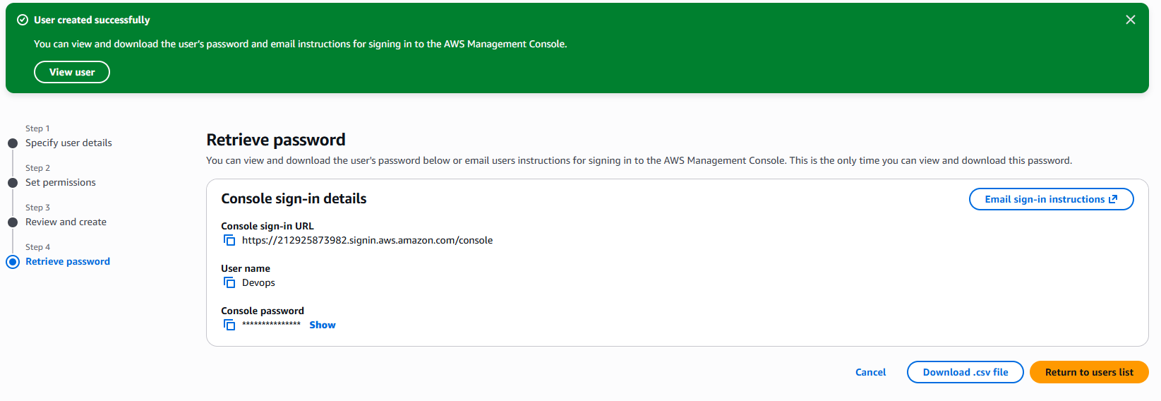
Download file and return to users list button. Now click on IAM User Group Button
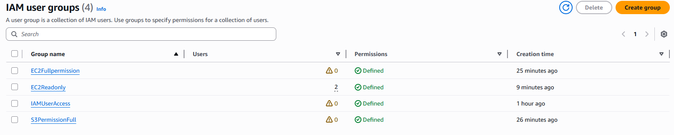
Select group which allow to user.
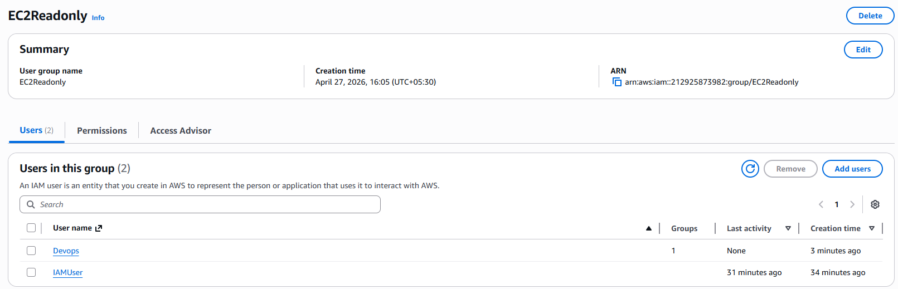

- Write a bash script to create an IAM user with VPC full access.
#!/bin/bash

--------- CONFIG ---------
USER_NAME="vpc-user"
POLICY_ARN="arn:aws:iam::aws:policy/AmazonVPCFullAccess"

--------------------------
echo "Creating IAM user: $USER_NAME"
aws iam create-user --user-name "$USER_NAME"
echo "Attaching VPC Full Access policy"
aws iam attach-user-policy
--user-name "$USER_NAME"
--policy-arn "$POLICY_ARN"
echo "Creating access keys (for CLI/SDK use)"
aws iam create-access-key --user-name "$USER_NAME"
echo "Done!"

- Create an IAM policy to allow EC2 access for a specific user in specific regions only.
Go to policy left side menu – create policy button – select json and write
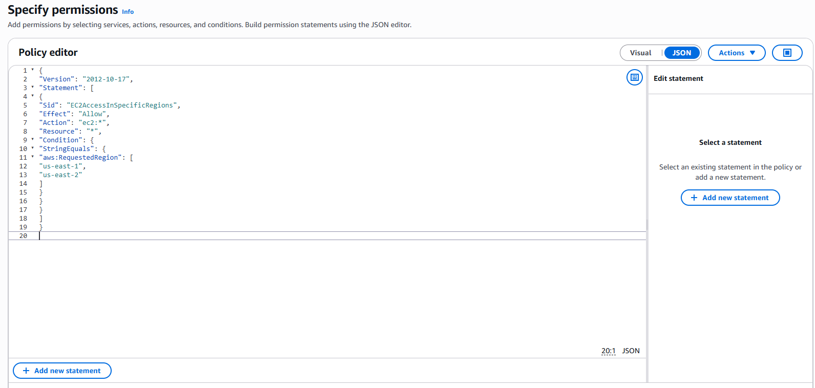
Now click on add next button.
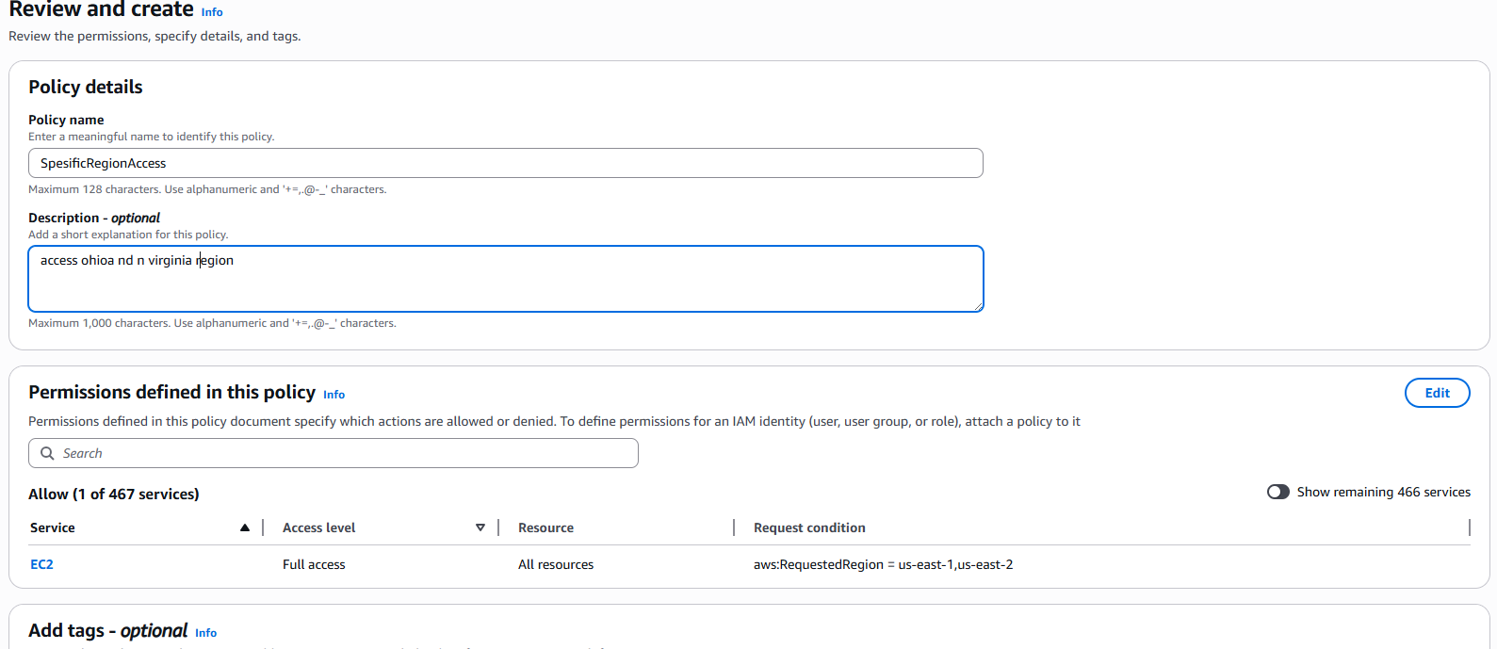
Now click on create policy button
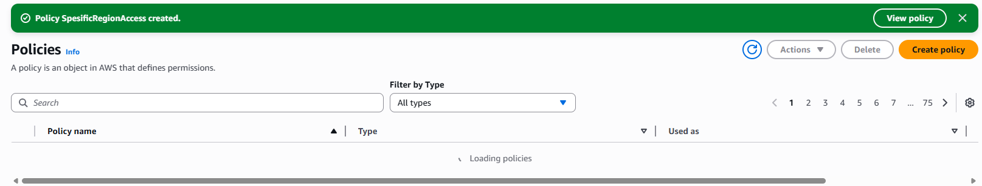
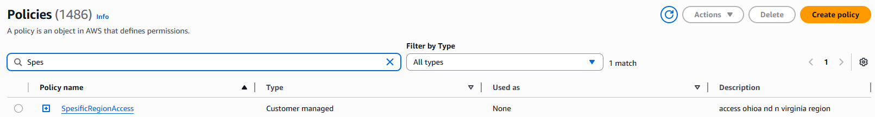
It show our policy.

